Exclusive Styling Packages
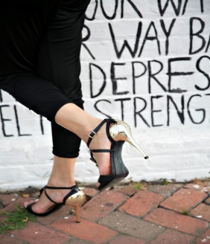
A Step In The Right Direction Package
Includes:
Consultation
Mood Board
Casual Attire to Shop for on Your Own
List of Stores to Shop at on Your Own
PRICE: $300

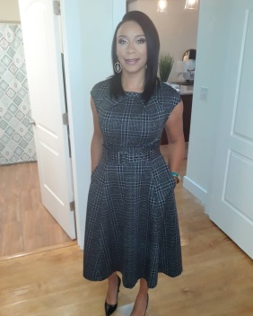
Yay! I’m On My Way to Personal Style Package
Includes:
Consultation
In-home Personal Shopping Session with Clothing from Retailer
Wine
H'ordeuvres
Professional Makeup
Professional Hair
Facial
Massage
PRICE: $2,000 (SERVICES ONLY, EXCLUDES CLOTHING BUDGET)
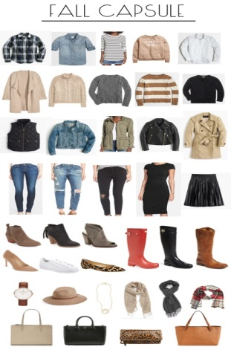
Declutter and Maximize Package
Capsule Wardrobe
(Staple pieces to assemble multiple and transitional outfits)
(INCLUDES A CLOSET CLEANSE)
PRICE: $600

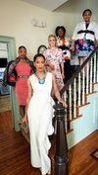
It’s Personal Package
All Day Personal Shopping with Predetermined Retail Stores
PRICE: $800
(SERVICES ONLY, EXCLUDES CLOTHING BUDGET)

